**Advanced Techniques for Wireless Sensor Networks**

**in Delay Critical Smart Grid Monitoring Applications**

by

Hussein T. Mouftah

Senior Canada Research Chair and Distinguished University Professor

School of Electrical Engineering and Computer Science

University of Ottawa, Ottawa, Ontario, Canada

[mouftah@uottawa.ca](mailto:mouftah@uottawa.ca)

Abstract

Cyber Physical Systems (CPSs) can significantly improve the resiliency of the Smart Grid. In CPSs, real time and reliable monitoring require an accurate and stable model of the Wireless Sensor Network (WSN)-based monitoring system. Furthermore, WSNs require strict Quality of Service (QoS) provisioning as the data generated by the monitored equipment is generally delay and reliability-sensitive. QoS provisioning in WSNs has been widely studied in the literature where most of the work addresses the issue by QoS-aware protocol design. However analytical models that consider delay, throughput, and power consumption have not matured for CPSs. In addition to that, in a CPS, if a given percentage of the data packets is not delivered to the base station or control unit, correctly and within a predefined deadline, the entire functionality of the sensing system may be jeopardized. We present advanced techniques suitable for the IEEE 802.15.4-based WSNs and present an adaptive QoS provisioning scheme for WSNs that provides service differentiation and reduces the delay of critical data in monitoring and control scenarios in a smart grid environment.

**Hussein T. Mouftah Photo and Short Bio:**

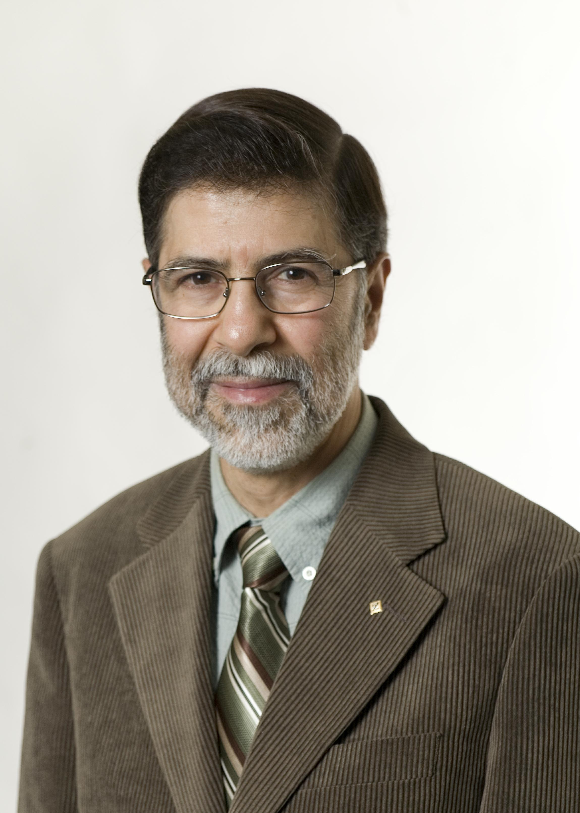**Hussein T. Mouftah** joined the School of Electrical Engineering and Computer Science (then known as SITE) of the University of Ottawa in 2002 as a Tier 1 Canada Research Chair Professor, where he became a *Distinguished University Professor* in 2006. He has been with the ECE Dept. at Queen's University (1979-2002), where he was prior to his departure a Full Professor and the Department Associate Head. He has six years of industrial experience mainly at Bell Northern Research of Ottawa (also known as Nortel Networks). He served as Editor-in-Chief of the IEEE Communications Magazine (1995-97) and IEEE ComSoc Director of Magazines (1998-99), Chair of the Awards Committee (2002-03), Director of Education (2006-07), and Member of the Board of Governors (1997-99 and 2006-07). He has been a Distinguished Speaker of the IEEE Communications Society (2000-2007). He is the author or coauthor of 9 books, 60 book chapters and more than 1300 technical papers, 11 patents, 7 invention disclosures and 140 industrial reports. He is the joint holder of 18 Best Paper Awards. He has received numerous prestigious awards, such as the 2007 Royal Society of Canada Thomas W. Eadie Medal, the 2007-2008 University of Ottawa Award for Excellence in Research, the 2008 ORION Leadership Award of Merit, the 2006 IEEE Canada McNaughton Gold Medal, the 2006 EIC Julian Smith Medal, the 2004 IEEE ComSoc Edwin Howard Armstrong Achievement Award, the 2004 George S. Glinski Award for Excellence in Research of the U of O Faculty of Engineering, the 1989 Engineering Medal for Research and Development of the Association of Professional Engineers of Ontario (PEO), and the Ontario Distinguished Researcher Award of the Ontario Innovation Trust. Dr. Mouftah is a Fellow of the IEEE (1990), the Canadian Academy of Engineering (2003), the Engineering Institute of Canada (2005) and the Royal Society of Canada RSC Academy of Science (2008).